**Cloud?**

Cloud is a term related to portability, where as cloud computing is referred as the term of portable computation, organizations don’t need to invest time in scaling and building hardware on premises rather they can now get cloud services to operate their basic operations.

**6 Benefits of Cloud Computing**

1. Pay as you go
2. Massive economies of scale
3. Massive capacity
4. Increases speed and agility
5. Saves money in maintaining data centres
6. Go global in minutes

**Types of Cloud Computing**

1. **Cloud:** Fully deployed in cloud and all parts of the application run in cloud. Applications could have either been created or migrated from existing infrastructure to take advantage of cloud computing.
2. **Private Cloud(on-premises):** On-premises using virtualization and resource management tools, is sometime called the private cloud. Increases more resource utilization using this.
3. **Hybrid:** Connects infrastructure and applications between cloud-based resources and existing resources that are not located in the cloud. Common method of hybrid deployment is between the cloud and existing on-premises infrastructure to extend.

**AWS Global Infrastructure**

**Availability Zone:** Cluster of more than one data centre that are connected to each other though high-speed data connection.

**Region:** Cluster of Availability Zone is called as region; the names of region are named after the location where they reside.

**Four aspects when deciding which region to host application and workloads**

1. **Latency:** Choose region close to your user base.
2. **Price:** Depends on local economy, prices may vary from one region to another.
3. **Service Availability:** Services are restricted across different regions.
4. **Data Compliance:** Customer data in enterprise companies to be stored in specific geographic territory.

**Interacting with AWS**

Every action in AWS is an API call. We can make these call using AWS Management Console, the AWS CLI or the AWS software development kits (SDKs).

**Features of AWS Management Console**

**Navigate to AWS service consoles** – You can use Unified Navigation to access recently visited service consoles, view and add services to your Favosites list, access your console settings, and access AWS User Notifications.

**Search for AWS services and other AWS information** – use Unified Search to search for AWS services and features, and AWS marketplace products.

**Customize the console** – You can use Unified settings to customize various aspects of the AWS Management Console. This includes the language, default Region, and more.

**Run CLI commands** – AWS Cloud Shell is accessible directly from the console. You can use Cloud Shell to run AWS CLI commands against your favourite services.

**Access all AWS event notifications** – You can use the AWS Management Console to access notifications from AWS User Notifications and AWS Health.

**Customize AWS Console Home** – You can completely customize your AWS Console Home experience by using widgets.

**Create and manage AWS applications** – Manage and monitor the cost, health, security posture, and performance of your applications using my Applications in AWS Console Home.

**Chat with Amazon Q –** You can get Generative Artificial Intelligence (AI) assistant powered answers to your AWS service questions directly from the console. You can also get connected with a live agent for additional support.

**Control AWS account access in your network** – You can use AWS Management Console Private Access to limit access to the AWS Management Console to a specified set of known AWS accounts when the traffic originates from within your network.

**Security and the AWS Shared Responsibility Model**

Security of Cloud vs Security in the cloud

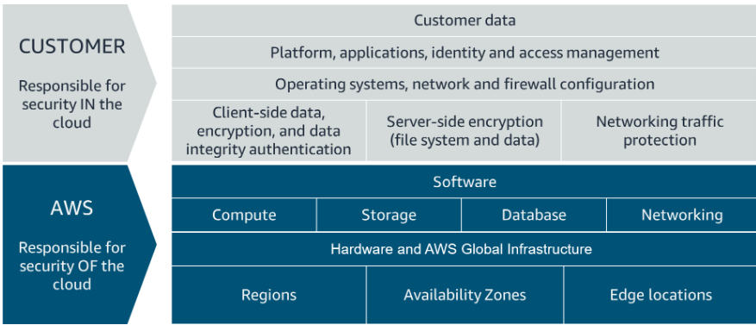

**AWS Responsibility**

* Protecting and securing AWS Regions, Availability Zones, and data centers, down to the physical security of the building
* Managing the hardware, software, and networking components that run AWS services, such as the physical server, host operating systems, virtualization layers, and AWS networking components

**Classification of Services into 3 different categories**.

| **Category** | **Examples of AWS Services in the Category** | **AWS Responsibility** |
| --- | --- | --- |
| Infrastructure services | Compute services, such as Amazon Elastic Compute Cloud (Amazon EC2) | AWS manages the underlying infrastructure and foundation services. |
| Container services | Services that require less management from the customer, such as Amazon Relational Database Service (Amazon RDS) | AWS manages the underlying infrastructure and foundation services, operating system, and application platform. |
| Abstracted services | Services that require very little management from the customer, such as Amazon Simple Storage Service (Amazon S3) | AWS operates the infrastructure layer, operating system, and platforms, as well as server-side encryption and data protection. |

**Customer Responsibility**

| **Category** | **AWS Responsibility** | **Customer Responsibility** |
| --- | --- | --- |
| Infrastructure services | AWS manages the infrastructure and foundation services. | You control the operating system and application platform, as well as encrypting, protecting, and managing customer data. |
| Container services | AWS manages the infrastructure and foundation services, operating system, and application platform. | You are responsible for customer data, encrypting that data, and protecting it through network firewalls and backups. |
| Abstracted services | AWS operates the infrastructure layer, operating system, and platforms, as well as server-side encryption and data protection. | You are responsible for managing customer data and protecting it through client-side encryption. |

**Protect the AWS Root User**

* Has all of the power
* MFA: Multi-Factor Authentication

**Review Supported MFA Devices**

AWS supports a variety of MFA mechanisms, such as virtual MFA devices, hardware devices, and Universal 2nd Factor (U2F) security keys. For instructions on how to set up each method, check out the Resources section.

|  |  |  |
| --- | --- | --- |
| Device | Description | Supported Devices |
| Virtual MFA | A software app that runs on a phone or other device that provides a one-time passcode. Keep in mind that these applications can run on unsecured mobile devices, and because of that, may not provide the same level of security as hardware or U2F devices. | Authy, Duo Mobile, LastPass Authenticator, Microsoft Authenticator, Google Authenticator |
| Hardware | A hardware device, generally a key fob or display card device that generates a one-time six-digit numeric code | Key fob, display card |
| U2F | A hardware device that you plug into a USB port on your computer | YubiKey |

**Every Thing in AWS is an API Call**